DMP is Celebrating International Pi-day, 2019
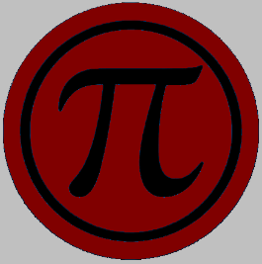
Department of Mathematics and Physics (DMP) is going to celebrate the International Pi-day on Thursday, 14th March, 2019. Pi is the ratio of the circumference of a circle to its diameter. It is symbolized by the Greek letter pi in the lower case (π). This is a fixed quantity, which is usually taken to be 3.14. The number of digits after the decimal is infinite and non-repeating.
This year DMP would like to celebrate the Pi-day on a larger scale. The celebration includes three contests mentioned below from 10am to 12pm on 14th March, 2019, followed by the prize and certificate giving ceremony from 2pm to 4pm in Audi 801.
Contests:
- A contest for the students to memorize number of digits of pi after the decimal point
- A contest to find the area of a circle using a ruler and string only
- Pi Sketching Contest

We are expecting maximum 50 contestants chosen on the first come first serve basis. If you are interested in participating, please collect the registration form from DMP main office.

We are hoping that the honorable Vice-Chancellor along with other administrative dignitaries will attend the program. The participants will be given a T-shirt as a souvenir and refreshment will be served at the end of the program.

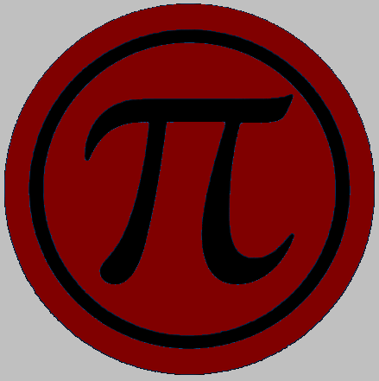
International Pi-day, 2019

Department of Mathematics & Physics
North South University

Registration Form

Contestant No.:………………. Photo
(To be filled up by Registration Sub-Committee)

Name of Contestant:
Gender (Male/Female):
Department/Discipline:
No of Semesters the contestant has studied in NSU till date:
Student ID No.:
Cell No. :
E-mail Address:

