IML Discourse I
NSU holds discussion on ‘Bangla Bhasha’
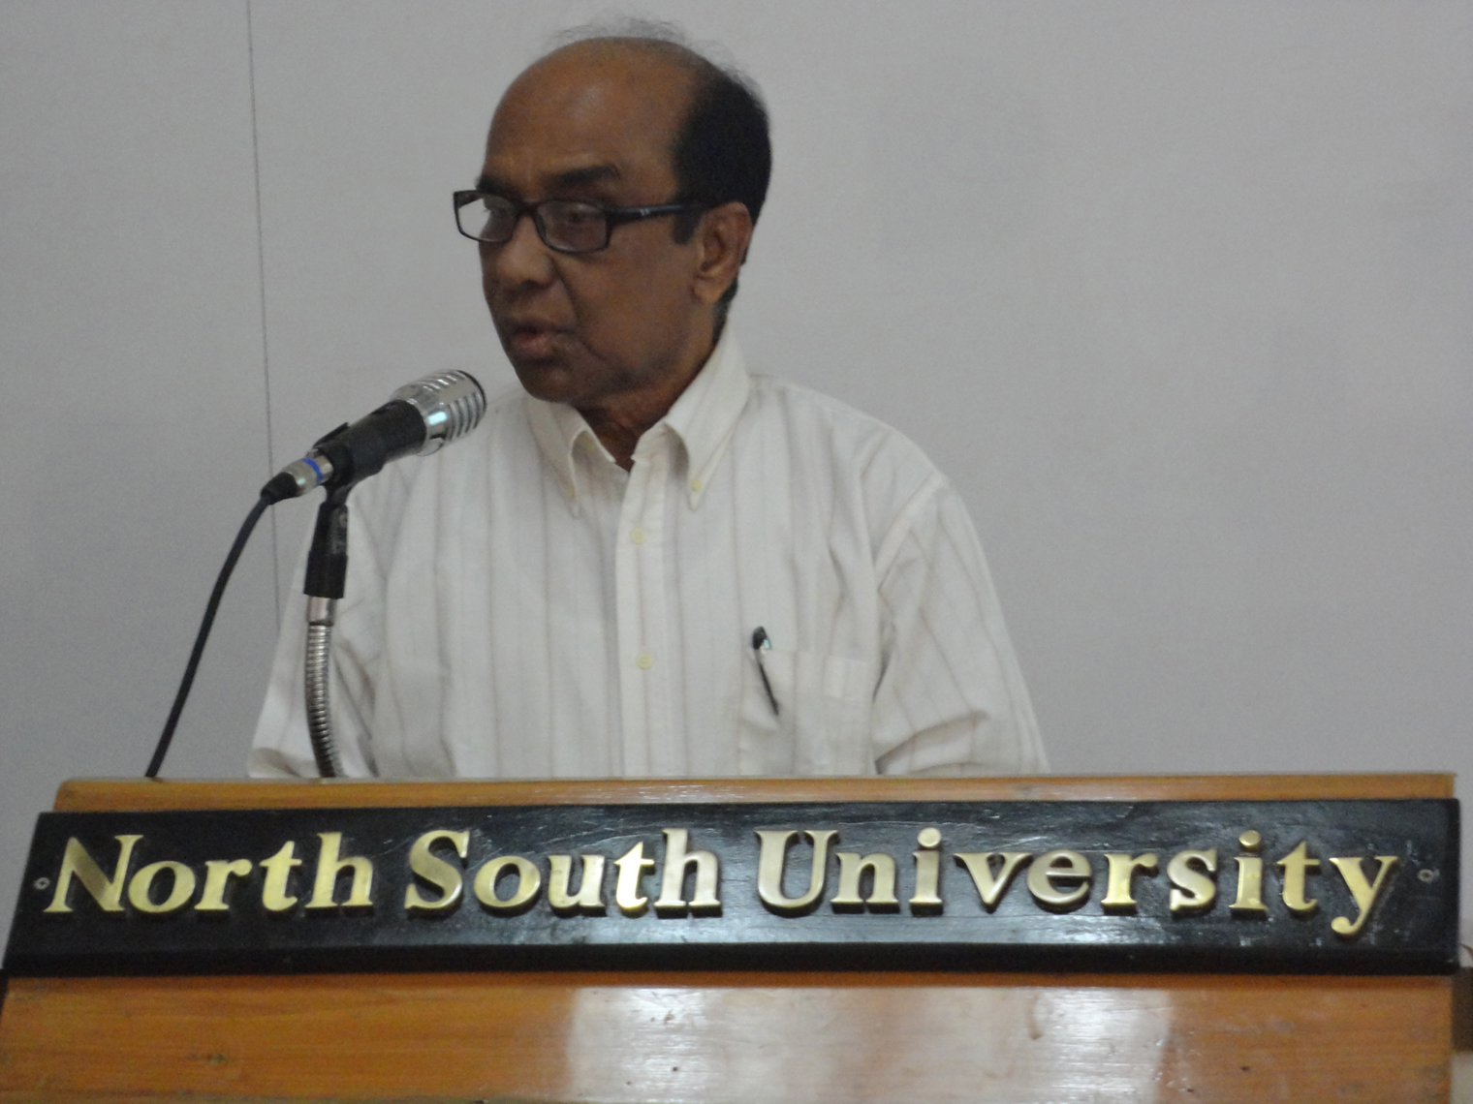
Mr. Shamsuzzaman Khan, Director General, Bangla Academy, and former Director General, Shilpokala Academy of Bangladesh, presented a discourse on language with special reference to codification and standardization of the Bengali language at NSU’s Institute of Modern Languages on February 27, 2013. The event was a special session of the Institute’s high-profile lecture series IML Discourse I. A good number of students of NSU attended the discourse Standardizing Bangla.
Although Bangladesh, unlike many other countries of the world, is not vast enough to be easily pointed out in a world atlas, it is surprising that the linguistic diversity we share in this country is so strikingly high. The regional quirky dialects of the Bengali language are peculiar to particular communities. People other than those who belong elsewhere may have to be ready to face eccentricity and twist of meaning. Sometimes, it could be daunting to have a bitter response from other community members when the meaning rendered by the speaker in his own dialect is different from the listener’s. These are some of the reasons, which has remained shadowed for long, why two like-minded and enthusiastic academics – Mr. Shamsuzzaman Khan and Mr. M Shahedul Haque - have recently taken an initiative to present an inspirational and illuminating discourse on the Bangla Bhasha on February 27, 2013 at NSU. An enthusiastic presence of students from English, business administration and other departments made this special event a grand success.
Language of national identity

Mr. M. Shahedul Haque, Head of IML at NSU, in his introductory speech outlined the concept of codification of a language and said that standardization of a language can preserve and protect not only the originality of a language but also the cultures associated with it. He said that while gradual transformations are natural and unstoppable in the development of a language, there is always an issue of acceptable form and frame of reference for usage, lexical preference, syntax, and grammaticality of linguistic expressions.
Mr. Haque said it was the ‘Bangla Bhasha’ which was at the heart of the conflict between us and enemy Pakistan in 1952 which inspired the historical ‘Language Movement’ that paved the way to the independence of Bangladesh in 1971 for which millions of Bengali speakers laid down their lives. The series of events simply has not match in the history of the mankind. It is due to Bangla and the Language Movement of 1952 that February 21 is now observed as the International Mother Language Day around the world. Indeed Bangla Bhasha represents our sovereignty, pride, unity and identity. Therefore, the language deserves to be linguistically codified and standardized in Bangladesh. He, on behalf of the University, highly appreciated the efforts made by Bangla Academy about this matter.

Bangla Bhasha represents our sovereignty, pride, unity, and identity

The issue of ‘pure’ Bangla

Our Language Martyr’s Day, 21st February, has a special significance for us since this is the day when a conspiracy was defeated by us which was hatched to annihilate our culture and language. Perhaps, this is the only occasion when a nation had to sacrifice so many of its children’s’ lives to defend its own mother tongue. This is why the entire world recognizes this day by giving it the honor of the International Mother Language Day. But yet, what should be our Bangla for common day-to-day use? Should it be the colloquial Bangla that we ordinarily speak in? Or should it be what is known as Promito Bangla? The current Head of Bangla Academy particularly focused on this point along with a brief history of Bangla language in his lecture.
In the beginning of his presentation, the Bangla Academy chief Mr. Shamsuzzaman Khan recalled the significance of the historic ‘Language Movement’ in 1952. He said that the Language Movement was deeply associated with the national identity of Bangla-speaking people around the world.
Mr. Shamsuzzaman Khan said that the much debated issue of the “Standard Bangla” arises when someone tries to impose their opinion as authority of language. Some people even criticize the colloquial version of Bangla, especially one that is used in the popular programs on TV. Again, there is this controversy of West Bengal Bangla and Bangladeshi Bangla.

The debated issue of the ‘Standard Bangla’ arises when someone tries to impose their opinion as authority of language

The process of the standardizing Bengali spelling was formally undertaken not until the year 1936 when the University of Calcutta introduced a series of spelling reforms to standardize the Bengali language. These reforms, however, were not uniformly accepted and a variety of alternative efforts toward standardization have been made by other institutions, such as the Bangla Academy in Dhaka and the Bishwa-Varati University of West Bengal. The variety of spelling reforms in Bangla is even more confusing especially when many Bengali language publishers and newspapers use their own styles, and it is an obvious fact that the great diversity of efforts made by different groups in hopes of standardizing the Bengali language has actually hindered the production of a uniform standardized Bengali language, namely — Promito Bangla.
The Standard Language Movement

Mr. Shamsuzzaman Khan pointed out that Bengali includes two basic styles: the colloquial speech known as Chalitobhasa and the formal speech known as Shadhubhasha. Differences between the two are evident primarily in terms of vocabulary and Chalitobhasa contraction of pronouns and verbs. After the publication of Shobujpotro by the eminent figure in Bangla literature Promoth Chowdhury, Chalitobhasa has now become Bengali’s leading literary language as well as its primary means of everyday communication. In addition, a number of regional dialects exist within the Bengali language. The way how the people from Sylhet speak is completely different from the way how the people from Chittagong speak. That is why the necessity of standardizing Bangla rises, which was first realized by the Noble laureate Rabindranath Tagore. In 1901 in the newspaper ‘Bongio Shahitto Parishad’ he started the movement to standardize Bangla where he wrote that the grammar that had been used so long is the grammar that belongs to the ‘Sanskrit’ language and sometimes there is also the influence of Latin. Consequently, there is no purity of the Bengali Language. This movement was accompanied by Dineshchandra Sen, Haraprashad Shastri and Ramendra Shundar Tribedi but in these 110 years it is yet to be done. The reason of this failure is the Bangla used by the West Bengal Hindu community in Calcutta has similarity with their Indian language and culture; so they are not inclined to accept the Bangla wholly that we use in Bangladesh. And, indeed, we also have differences in Chalito Bangla. So by combining the Bangla of two regions an effort has been taken to standardize Bangla since 2009 which brought forth “Promito Bangla Bekoron” (Standard Bangla Grammar) in 2012.

When it comes to literature, it will be seen that, though it conforms to the rules of grammar, it is yet a thing of joy; it is freedom itself

Rabindranath Tagore

Bangla exhibits important differences between the written and spoken forms of the language.
Two styles of writing, involving somewhat different vocabularies and syntax, have emerged:
- Shadhu bhasha (shadhu='chaste' or 'sage' and bhasha='language') is the written language with longer verb inflections and more of a Pali/Sanskrit/Totshomo-derived vocabulary. Highly literary and classic songs such as India's national anthem Jana Gana Mana (by Rabindranath Tagore) and national song Vande Mātaram (by Bankim Chandra Chattopadhyay) were composed in Shadhubhasha. However, use of Shadhubhasha in modern writing is uncommon, and restricted to some official signs and documents in Bangladesh as well as for achieving particular literary effects.

- Cholito bhasha (cholito='current' or 'running'), known by linguists as Shisto (gentle) Cholit Bangla (Standard Colloquial Bengali), is a written Bengali style exhibiting an abundance of colloquial idioms and shortened verb forms, and is the standard for written Bengali now. This form came into vogue officially from the year 1914 in which the famous literary supplement “Shobuj Potro” was published by Pramatha Chowdhury and later, in the writings of Rabindranath Tagore. This variety of Bangla was modeled on the dialect that was spoken in the Shantipur region at Nadia district in West Bengal. This variety of Bangla is also referred to as the "Nadia standard" or "Shantipuri Bangla".
While most writing is in Standard Colloquial Bengali, spoken dialects exhibit a greater variety. People in South-eastern West Bengal, including Kolkata, speak in Standard Colloquial Bengali. People in other parts of West Bengal and western Bangladesh speak in dialects that are minor variations, such as the Medinipur dialect characterized by some unique words and constructions. However, a majority in Bangladesh speak in dialects notably different from Standard Colloquial Bengali. Some dialects, particularly those of the Chittagong region, bear only a superficial resemblance to Standard Colloquial Bengali.
Spoken Bengali exhibits far more variation than written Bengali. Formal spoken Bengali, including what is heard in news reports, speeches, announcements, and lectures, is modeled on Choltibhasha. This form of spoken Bengali stands alongside other spoken dialects, or Ancholik Bangla (i.e. 'regional Bengali'). The majority of Bengalis are able to communicate in more than one dialect — often, speakers are fluent in Choltibhasha, one or more Ancholik dialect, and one or more forms of Gramyo Bangla (i.e. 'rural Bengali'), dialects specific to a village or town. Even in Standard Colloquial Bengali, Muslims and Hindu use different words. Due to cultural and religious traditions, Hindus and Muslims might use, respectively, Pali/Sanskrit-derived and Perso-Arabic words.^{[46]} Some examples of lexical alternation between these two forms are:
- hello: nomoshkar (S) corresponds to assalamualaikum/salam (A)
- invitation: nimontron/nimontonno (S) corresponds to dawat (A)
- water : jol (S) corresponds to paani (S)
- father : baba (P) corresponds to abbu/abba (A)
(Here, S=derived from Sanskrit and/or Pali, P=derived from Persian, A=derived from Arabic)
All the above controversies converged finally into the “Promito Bakoron Andolon” (The Standard Language Movement) in the year 1901 pioneered by Rabindranath Tagore. The beginning of this particular language movement was originally in the West Bengal. On the land of Bangladesh, it’s Bangla Academy to take up the helm of this movement. It is a matter of pride for all of us—the Bangladeshis that for the first time in the history of this country “Promito Bangla Grammar” has been published by Bangla Academy in the years 2009 to 2012, and the process of modification is still in progress.
Range of linguistic influence

The entire event was mostly centered on Bangla spectrum although the range of the discussion by Mr. Shamsuzzaman Khan embraces many other aspects associated with language such as art, sign-language, semantics etc. He highlights the importance of art as a language reflecting on an anecdote relating to Bengali artists, Jaynul Abedin, managed to get away with the trouble he faced buying food because of his inability to speak their language. Finally, Jaynul managed to get rid of the problem when he suddenly turned clever and applied his artistic means to make the seller understand by drawing a picture of the food item that he wanted. The speaker also touched on the evolutionary history of Bangla and talked a little bit about the borrowings of Bangla language from other languages, for example, Portuguese, Chinese, and English etc. The description of how the economy of a county can be one of the primary forces that drives the expansion of a language beyond its frontiers and necessitates others to use it as lingua franca in different business transactions also came into his discussion. He further clarified the point by quoting the names of such economies, USA, China etc.
According to the Head of Bangla Academy, language can be enriched by not only the linguistic resources of itself but also those of other languages. For instance, some English words have their origin in Bangla. Similarly, in the Bengali Language a good number of words have been borrowed from different languages of the world for various reasons in different times. In this respect a lot of words from Sanskrit, Arabic, Farsi, Portuguese, Turkish, Hindi etc. occupied the Bengali dictionary to a great extent.
Toward reaching a standard model

Now it was towards the end of the event the most vital concern come up in discussion. It was more or less a unanimous decision made by the speaker, Mr. Shamsuzzaman along with the audience that there should be a standard model for all though it could be hard to achieve. He mentions that an integrated effort by the two major Bangla speaking parts Bangladesh and Calcutta can work better in standardizing Bengali language: Recently, they published a ‘Standardized Bangla Grammar’. Next, he stresses that the media should act side by side as a helping agent to make the ‘Popular Edition’ available for general population. To avoid any further fear he assured ‘standardization doesn’t mean elimination of any particular dialect but to teach people a standard version in common’.
While referring to the rich and complex dialect spectrum of the Bengali language, he pointed out that borrowings enriched almost all forms of Bengali.
The concluding remarks were ambitious and were followed by a question answer session. Students posed questions enthusiastically and enjoyed being part of the event. The event was saturated with curiosity and response from the audience who appreciated being participants in such a typical but innovative and revolutionary seminar. Finally the event ended with an exchange of applause and admiration and with a long reaching hope among the audience and the speakers.

Written by the participating members of the IML Research and Information Team

