IML Presidential Discourse: Language and Politics
We mourn the death of our beloved President Zillur Rahman who was one of the enlisted guest speakers (Institute Faculty) of the Institute of Modern Languages at NSU.

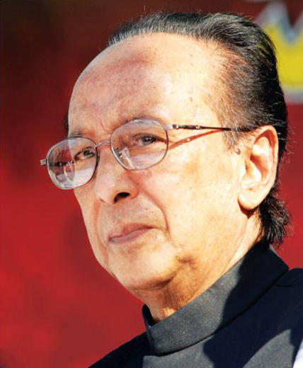

A career politician turned President of People’s Republic of Bangladesh, he was indeed the most appropriate individual to present the IML Presidential Discourse on Language and Politics for the students of NSU.
Although it was clear that he was unable to come to NSU after his retirement in 2014, due to the communications and the encouragement, he will always remain as a source of inspiration for all of us at the Institute of Modern Languages at NSU.
- Director, IML

