Institute of Modern Languages

IML Workshop Series

Session 9

“Reporting Events”

Grabbing the morning newspaper is the first thing for most people after waking up from a goodnight’s sleep. We glance over the paper for the breaking news by hardly paying attention to the unique structure, style and language of the reports. Nevertheless, this unique news style is the hidden strength of any report that enriches the readability of the news and this difficult job of discovering information and describing events are done by millions of reporters and editors everyday around the globe. In order to be enlightened on this issue, North South University (NSU) students participated in the IML Workshop Series’ session 9 on Reporting Events organized by the Institute of Modern Languages (IML) at NSU on October 15, 2012. The event was attended by a good number of IML, English, BBA and Engineering Department students of NSU.
The session “Reporting Events” was conducted by Mrs. Tasneem Tayeb Kabir, Content Planner and Editor of the popular “Y&I” magazine of The Independent (Newspaper). It may be mentioned that she was awarded the Chancellor’s Gold Medal in the 15th convocation of North South University for her extraordinary 4.0 CGPA from the Department of English, NSU. The objective of her workshop was to give a hands-on experience of generating news style as well as to guide them to become future news reporters.
The Real Touch of Journalism…
The event began when the students got the real touch of journalism by flipping through the different editions of Y&I they were provided with while listening to the respectable speaker. The students were burning with curiosity and thus asked several questions throughout the event. Their active participation made the workshop vibrant and lively. The students shared their basic knowledge about reporting events and described news in their own ways like “What’s new, that’s the news!”

The Use of Inverted Pyramid Structure in News Stories…
The most common metaphor, the inverted pyramid used by the journalists was brilliantly illustrated by the guest speaker. She simultaneously highlighted the pyramid structure to illuminate the differences between a news report and a featured article. The inverted pyramid structure is used by the journalists while writing the news stories as they usually explicate the most important information at the very beginning of the report and then gradually taper off the report by putting the least important information at the end. Thus the whole story takes the shape of a triangle resembling the inverted or upside-down pyramid.
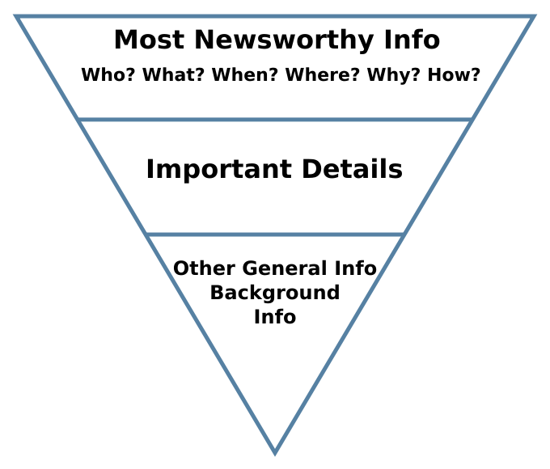This structure is particularly common among the journalists as it enhances the readability of the stories and grabs the attention of a large readership. It allows the readers to leave the story at any point after grasping the significant points if they do not want to linger through the details. This also makes the work of the editors feasible as they can remove the general information by cutting a report from the bottom so that it can fit a fixed format. The honorable speaker explicated the structure in minute detail by using various news examples from real life which assisted the students to visualize different types of stories. Nevertheless, the newspaper also publishes longer articles or features which are usually written for the supplements. These articles differ from the cut-throat approach of the inverted pyramid structure as these start with speculations, anecdotes or general information and thus follow the pyramid structure. The examples of this featured article were also prominently illustrated by the speaker.
Reporting is not only writing but also discovering information!
While explaining the value of reporting, she mentioned that a reporter not only writes the stories but also digs up information which requires passion, patience and perseverance. The reporters need to be prepared to cover an event and respond to an emergency all the time. Sometimes s/he needs to risk his/her own life to let the cat out of the bag while creating an investigative report. This job of writing an in-depth report is assigned to some specialized reporters who are known as “beat reporters.” Therefore, the tasks of the reporters vary from person to person.
Although this enthralling workshop was for a short period of time, students got a vivid idea about reporting events as the honorable speaker precisely illuminated the details using real-life examples. Students actively participated throughout the events and their glowing interests became prominent when they asked the speaker how they can start their careers as reporters or editors. She pointed out that developing the habit of free-hand writing is of paramount importance to become a reporter as s/he should try to publish articles in different newspapers and magazines. Therefore, she emphasized on the practice of writing. Thus this vibrant workshop came to an end with the hope that it planted the seed of journalism in some prospective reporters or editors. Therefore, when I glanced at the glowing faces coming out of the room, it felt like I was looking at some future men with pens.

Written by a participant in the event

