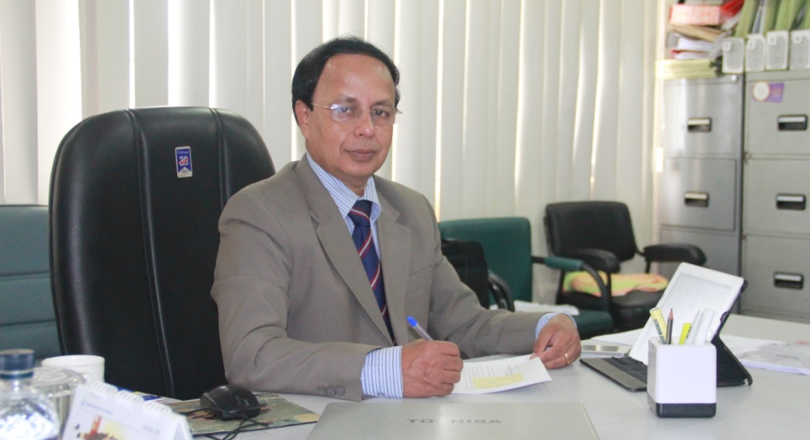

Prof. Dr. G.U. Ahsan, Dean, School of Health & Life Sciences has been selected as the member of Bangladesh Delegation for the 68th World Health Assembly to be held in Geneva, Switzerland during May 18 to 28, 2015.
This is the highest Assembly of World Health Organization (WHO), where North South University is recognized with high value and honor due to the selection of Prof. Ahsan as the Member of Bangladesh Delegation.
All the Health Minister and Health Secretary of the member countries of the world will attend this Assembly. Prof. Ahsan has been working as the Member of the Technical Advisory Committee of South East Asia Region Office (SEARO) of WHO.
Prof. Ahsan has also been contributing significantly in health policy formulation and sustainable development for quality health service in Bangladesh and in this region.
Prof. Ahsan will be leaving for Geneva on May 16, 2015 as a Delegation member of the Government of the Peoples’ Republic of Bangladesh. We wish his very fruitful contribution in this prestigious event!

