What is nonviolent communication?

Nonviolent communication is a type of communication which focuses on deep and compassionate awareness of one’s inner experience, listening to another with deep compassion, and express oneself authentically and honestly which likely inspires others to become compassionate.

Why should you attend this workshop?

You shall attend this workshop in order to increase greater authenticity in communication and deepening connection with self and others. It will improve your language and communication skills that strengthen your ability to remain human. Non violent communications replaces our old patterns of defending, withdrawing or attacking in the face of judgment and criticism, so that we can perceive ourselves and others.

Workshop on Nonviolent Communication

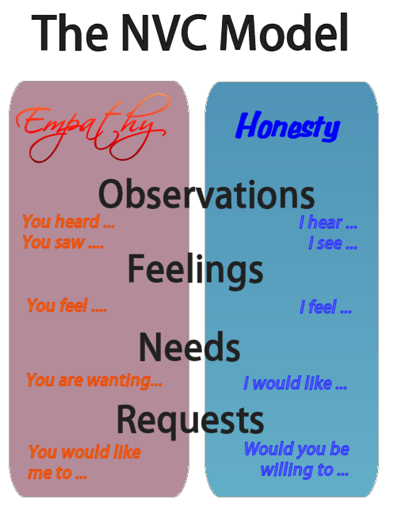

Date: 16/03/2016
Time: 2:00-4:00
Workshop duration: 2 hours
Venue: Faculty Lounge
Number of Participants: 30
Category of participants: STUDENTS ONLY

Where can you apply nonviolent communication?

You can apply in your personal, family life, in your intimate relationships, with children, in organization and Institution and many more situations.

Presenter: Lipy Gloria Rozario
Student Counselor and Acting Office Head

To attend: e-mail: shaphawat.hossain@northsouth.edu
Please mention Non Violent Communication on subject

First come first served basis

Date: 24/03/2016
Time: 2:00-4:00
Workshop duration: 2 hours
Venue: Faculty Lounge
Number of Participants: 30
Category of participants: STAFF ONLY

