**12th Death Anniversary**

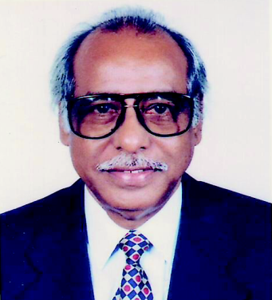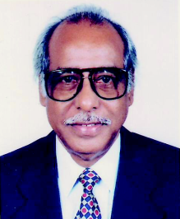

We pray for Marhum M. Masihur Rahman on his 12th death anniversary today, the 10th June 2014. Marhum Masihur Rahman was the Founder Life Member of the North South University (NSU) Foundation, which established NSU and, later, constituted the NSU Trust, which runs NSU now. He was also the Founder Life Member of the Board of Governors, NSU Foundation and Member of the then Parichalona Porshod, NSU.

He was a successful industrialist, promising banker and enthusiastic philanthropist who breathed his last on 10th June 2002.

May Allah bless his departed soul and give the members of his family the strength to keep on bearing the loss.



**Members of**

**North South University Foundation**

**North South University Trust**

**North South University**